**Harry Franklin, N11722177 – IGB283 Assignment 2 – Workshops**

**Workshop 6**

* Activity 1 – Rotating Cube

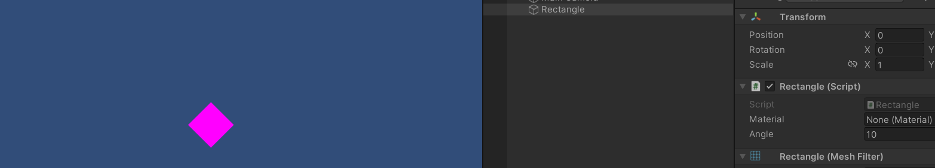This activity has no controls as the Rectangle script rotates the cube forever.

* Activity 2 – Planets

This activity has no controls. The planets are set up with fairly realistic sizes and distances from the sun. Each has their own orbit speed which is not based on real physics.

**Workshop 7**

* Activity 1

This activity is controlled by the 3 sliders which rotate their respective limb.

**Workshop 8**

* Activity 1

This activity is controlled by the public variables for Angle in the script.

* Activity 2

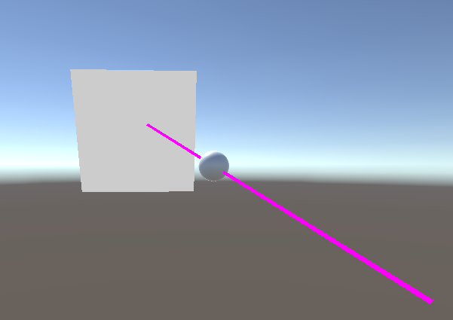

This activity has no controls.

**Workshop 9**

* Activity 1 and 2

This activity has no controls, and outputs the number of intersections in the Console.

* A screenshot of a computer

  Description automatically generatedActivity 3

The console and text in the top-right corner states whether the point is inside or outside the circle.

**Workshop 10**

* Activity 1
* A paper with math equations and formulas

  Description automatically generated

Activity 1 was done on paper during the workshop.

* Activity 2  
  **A graph with lines and dots

  Description automatically generatedA line of dots and lines

  Description automatically generated**

This is controlled by left clicking and dragging circles to move them and right clicking circles to delete them.

**Workshop 11**

* Activity 1

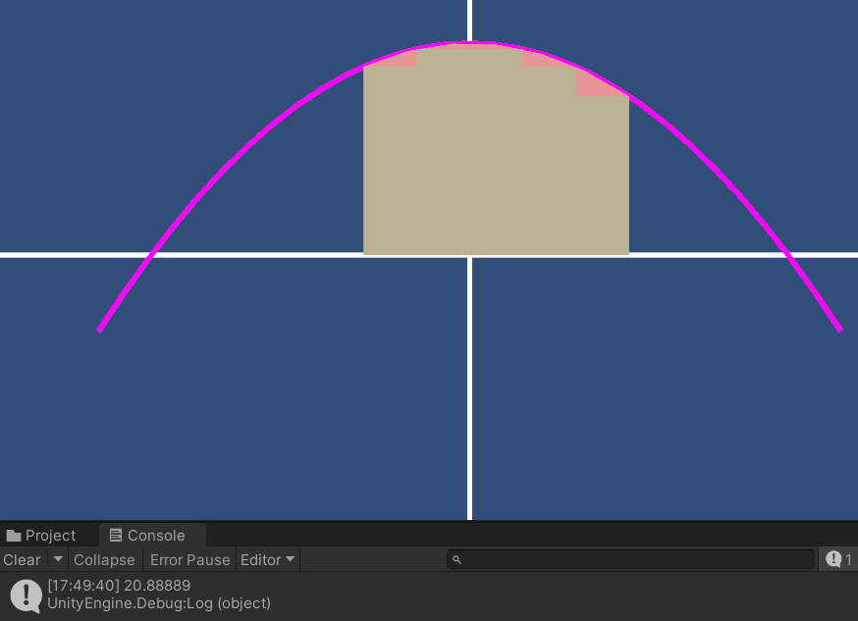

This activity has no controls, and outputs the area under the curve and above the x-axis.

**Summary**

* As far as I can tell, every required Workshop is present in this document, and attached as Unity projects.